FACULTY EVALUATION
Programme Name: SBVP ALUMNI MASTERCLASS Online s Module 2 Zambia (4th May 2026 - 8th May 2026)
Session: enterprise|| Identify Funding Gaps|| Preparing funding plan
Faculty Name: Dr. Chilumba Bwalya
No. of Respondents: 7
No. of Participants: 10
Evaluation Parameter | (%) Individual Score | (%) Programme Average
Punctuality (Commencement and Completion of Sessions) | 94 | 95
How well do you understand the core concepts presented? | 91 | 88
Rate your confidence in applying the new skills learnt | 94 | 85
Degree of Faculty preparedness for the sessions | 94 | 93
Content and methodology of the program | 100 | 95
Quality of class and group discussions | 91 | 91
The information presented in the course is relevant to my work (ministry) | 97 | 95
Average scores | 94 | 92

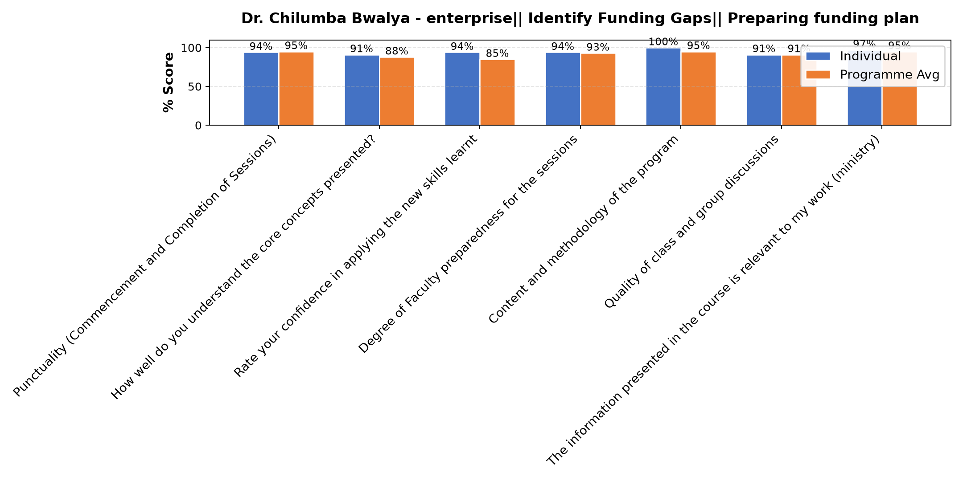

Comments & Feedback
- • No barriers will prevent me from applying what I have learnt
- • Network challenge to most partucioants
- • Today there were few sisters yet the content way very important
- • I had challenges of network
- • Lack of enough finances to achieve the demands of our stakeholder ( parents of our learners)
- • Lack of time. Too busy at the moment
SUBMITTED THROUGH:
SBS Evaluation Automation System

